CH 3.2.0

User’s guide for CH Data Manager

Programmer: Claude Hanssens

Basic description of CH Programs 3.0
This program has been developed for Microsoft Flight Simulator on the Internet or a local network. It is also possible to use CH Programs on a single computer or over the Internet.

The program is actually composed of 3 separate programs:
- The CH Client 3.0
- The CH Server 3.0
- The CH Data Manager 3.2.0

The CH Client takes information from Flight Simulator 98, 2000, or 2002 and sends it to the CH Server through a TCP/IP network. The CH Server displays the information received from the client’s flight simulator through CH Client. The information in CH Server will be displayed in a tabular format on a special form. Another form will show the aircraft on a radar screen. This radar screen will also display other information like NAVAIDS (VOR, NDB, frequencies...), geographical data and airports. This information is taken from a Microsoft Access database. The CH Server part has also the capacity to generate “Devil orders”. These are commands sent to the flight simulator when connected. The server can manipulate the weather environment, aircraft systems, position and navigational equipment. CH Server has been designed to act as a host and a server client. People can use the program to connect multiple pilot and air traffic controller users into a network. CH Data Manager allows the user to add, edit or delete data from the CH database.

Version and Upgrade
Actual version of CH Data Manager is 3.2.0.
There will be upgrades to this version.
These upgrades can be minor upgrades, major upgrades or fully new version.

CH Data Manager V2.0.0 can read data from CH Databases V2.0.0.
If you want CH Server 3.0 to act as Main Server using your CH V2.0 database, then you must update your database to V3.0.0 using CH Data Manager 3.2.0.

Changes since version 2.0.0

New:
Added: the Delete All feature in the ICAO screen
Added: the Delete All feature in the LINE screen
Added: the Export All feature in the ICAO screen
Added: the Export All feature in the LINE screen
Added: the Import CH Format feature
Added: the Import Prabal’s database Format feature
Added: the Import USGS database Format feature
Modified: JH Capture—no longer requires the FS98Class.dll
Added: the Update to V3 feature

Distribution
CH Programs is available:
- for download on the Internet
- on CD-Rom (made on request only by Claude Hanssens)

Both versions have exactly the same functionality.
The CD-Rom version also includes:
- Sound files

Installation of CH Data Manager
The CH Data Manager part must be installed if you wish to edit the CH Database. This part is NOT required for network flights. Microsoft Flight Simulator is not required on this computer. It is also possible to edit the CH Database directly with Microsoft Access 7.0 or later.
Note: Do not convert the CH Database to a later version than Microsoft Access 7.0.

If you have a previous version of CH Data Manager, you must first uninstall it:
- Start-Settings-Control Panel-Add/Remove programs
- Click on “CH Data Manager”, if in the list.
- Click on the "Remove" button.

To install CH Data Manager from the CD-Rom, simply run the “Setup” program in the folder “CH Data Manager”.
To install CH Data Manager from the Internet, first unzip the archive file into a temporary folder, then run the “Setup” program in the temporary folder.

The Setup will ask you a destination folder. You MUST install the CH Data Manager in the same folder as the CH Database you wish edit (CH Server directory).
You might need to restart your computer.

Very important:
If you wish to use JH Capture, you need to have some files installed (JH Capture uses the same libraries as CH Client):
- For FS98, FS2000 and FS2002, FSUIPC.dll version 2.77 or higher from Peter Dowson must be installed in the FS\Modules folder.
You can download at http://www.schiratti.com/dowson.html

User’s guide

General
The CH Server radar screen, displays not only aircraft data, but other information such as airports, VOR, NDB, Fixes, Runways, etc. This data is stored in a Microsoft Access database: the CH Database (CHData.mdb) located in the same directory as the CH Server. To edit CH Database data, you can use CH Data Manager. It is also possible to edit the CH Database using Microsoft Access.
CH Database V 3.2.0 will not contain data when downloaded. This decision was based on the following ideas:
- The original data is consistently outdated
- Every CH Server user must maintain his own database

From version 3, CH Data Manager contains import features for the following data:
- ARP (Airport Reference Point)
- VOR
- NDB
- FIXES
- Geographical data such as coast line, rivers, political boundaries
The other data, like detailed airport ground layout or runways, must always be entered the same way as before:
- manually entered
- captured by JH Capture
- drawn from the CH Server screen
But from version 3, the data (all types) can be exported in a standard format (CH Format) and imported. All existing data will be available as CH Format files (.chf), containing specific data (one airport, runways for one country, etc). Each CH Server user can then import only the data needed.
People having encoded (typed, captured or drawn) specific data can export them and make them available to other CH Server users. The CH Data Manager will edit the CH Database placed in the same folder as CH Data Manager itself. It includes an add-on: JH Capture which allows you to store data taken from the current position of your aircraft in flight simulator and extract it to the CH Database.

Note: CH Server will always use the CH Database placed in the same folder as CH Server itself.

Useful tip:
You can place CH Server and CH Data Manager in 2 separates folders. You then have to copy the CH Database (CHData.Mdb) in this folder of CH Data Manager. So you can edit the copy of the CH Database. To test your modifications, you must copy the modified CH Database back to the CH Server folder. If you are not satisfied with your modifications, you just have to restore your original CH Database.

Data sources
CH Data Manager uses 2 specific external data sources:
- Prabal’s Worldwide navigation database
- US Geographical Survey databases

Prabal’s Worldwide navigation database
Prabal’s Worldwide Navigation database is a database maintained by Ghosh Prabal. Prabal publishes this database for the FS community. He gives me the explicit permission to use it with CH Programs.
This database contains Airport, VOR, NDB and fixes from around the world. The database is updated monthly and is freeware. You can download it from Prabal’s web site: http://drive.to/prabal.
The Prabal’s Worldwide Navigation database is composed of 4 files (plus the ReadMe.txt: read this one first):
- Airports.dat: contains the list of airports with their coordinates. Note: small airports are not listed.
- Vor.dat: contains the list of Vor with their coordinates.
- Ndb.dat: contains the list of Ndb with their coordinates.
- Fixes.dat: contains the list of Fixes with their coordinates. This file also contains a list of “fictive” fixes placed at every latitude and longitude degree.
CH Data Manager can import data stored in those files. Note: the “fictive” fixes are not imported.

US Geographical Survey database
This web site publishes geographical data stored in various databases:
- World Coast Line (designed for 1:5.000.000): coast lines and lakes; worldwide
- World Data Bank II (designed for 1:2.000.000): coast lines, lakes, rivers, international and political boundaries; worldwide
- World Vector Shoreline (designed for 1:250.000): coast lines and political boundaries; worldwide
- NOAA/NOS (designed for 1:70.000): coast lines and political boundaries; United States only
You can download the data you need from the Coastline extractor web page: http://crusty.er.usgs.gov/coast/getcoast.html
My best choice is the World Data Bank II. This is the best trade-off between a good resolution and the amount of data to download and to display on the CH Server radar screen (the more data to display, the more time it will take draw the screen). For example, coastlines from the whole world at a resolution of 1:5.000.000 (from WCL) require more than 60.000 records in CH Database.
From the Coastline Extractor page, you have to specify:
- The northernmost and southernmost latitudes
- The easternmost and westernmost longitudes
- The required data source (resolution and data)

Note: there is a limit of 500.000 points for a single extraction.

From the Coastline Extractor page, you must choose the following options:
- Zip (will generate a zip file)
- Mapgen (the only one format useable by CH Data Manager)
- No Preview (preview is useless here)

When you click on Submit, the Coastline Extractor page will generated a zip file containing the requested data. You can then download the file.

Structure of CH Database
The CH Database contains three separate tables (lists of data):
- the ICAO table
- the LINE table
- the COLORS table

The ICAO table
This table contains all data that can be displayed as a point. There are 5 types of points:
- ARP: Airport Reference Point
- VOR
- NDB
- FIX: Fixes
- LABEL: information point such as taxiways name

For each point, you must give the following information:

Data Type | Description | Required | Example
Name | ICAO Code | X | BUN
Long Name | Long name |  | Bruno
Type | ARP, VOR, NDB, FIX or LABEL |  | VOR
Frequency | Frequency |  | 110.60
LatText | N or S | X | N
LatDeg | Degrees of Latitude | X | 51
LatMin | Minutes of Latitude | X | 4.39
LongText | E or W | X | E
LongDeg | Degrees of Longitude | X | 4
LongMin | Minutes of Longitude | X | 46.48

The LINE table
This table contains all data that must be displayed as a line: borders, airways, runways,...
There are 8 types of lines:
- HRUN: high runway: runways are displayed as a single line: generally used with a wide radar range.
- APP: approach: approach line to a runway
- LRUN: low runway: runways are displayed as rectangle (4 lines for each runway)
- TAXI: taxiways
- BOUN: sector boundaries: used to draw airspaces
- HI: high airways
- LO: low airways
- GEO: geographical data: used to draw the borders of countries
- REL: relief: mountains
- ROAD
- WATER: rivers, lakes
- BUILD: building, construction
- CUST1 to CUST5: custom: lines for the user

For each point, you must give the following information:

Data Type | Description | Required | Example
Name | Name for the line | X | EBBR 07L/25R
Type | HRUN, APP, LRUN, TAXI, BOUN, HI, LO GEO, REL, ROAD, WATER, BUILD, CUST1 to CUST5 | X | HRUN
OrLatText | N or S (origin of the line) | X | N
OrLatDeg | Degrees of Latitude (id) | X | 50
OrLatMin | Minutes of Latitude (id) | X | 54.057
OrLongText | E or W (id) | X | E
OrLongDeg | Degrees of Longitude (id) | X | 4
OrLongMin | Minutes of Longitude (id) | X | 27.667
DestLatText | N or S (end of the line) | X | N
DestLatDeg | Degrees of Latitude (id) | X | 50
DestLatMin | Minutes of Latitude (id) | X | 54.736
DestLongText | E or W (id) | X | E
DestLongDeg | Degrees of Longitude (id) | X | 4
DestLongMin | Minutes of Longitude (id) | X | 30.017
GlideSlopeDeg | Degree of the glideslope

(1) the field GlideSlopeDeg is required only for the APP type.

Special requirements for CH PAR:
CH PAR radar has some special data requirements. If the information is not correctly filled out, then CH PAR will not work.
- GlideSlopDeg must be filled for each line having “APP” as Type.
- the “Runways” combo-box in the CH PAR displays all lines having “HRUN” as Type.
- when a runway is selected, CH PAR will look for lines having “APP” as Type and having exactly the same name. I have always used the following name convention for a runway (“HRUN” Type) and his two approaches (“APP” Type): XXXX YY ZZ, where XXXX is the ICAO code of the airport, YY(Y) and ZZ(Z) are the 2 runway designators, the three are separated with a space. E.g.: EBBR 02 20 or EBBR 07L 25R.

The COLORS table
This table is used by the CH Radar to store the saved colors. Colors removed from the table will displayed on the CH Radar screen using the default color.

The SECURITY table
This table is used by the CH Server to store logins and permissions for CH Client and CH Server that connect to a Main Server using the database.

User Interface of CH Data Manager
When started, it looks like this:
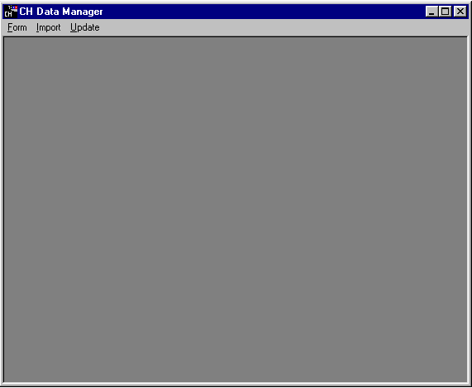

The Form menu has the following choices:
- ICAO
- LINE
- About: Display the “About” screen.
- Exit: to close the CH Data Manager

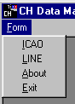

The Import menu has the following choices:
- CH Format
- Prabal’s database
- USGS database

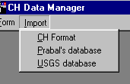

The Update menu has the following choice:
- ICAO

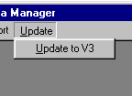

ICAO
This is the first item in the Form menu.
When opened, the ICAO screen looks like the picture below:

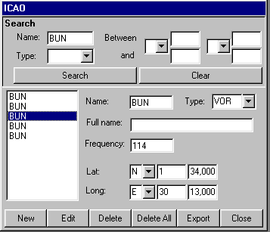

The screen is divided into 4 areas:
- the Search area above
- the List on the left
- the Menu area below
- the Data area on the right

The Search area allows you to enter selection criteria. Points responding to those criterias are listed in the list. The Data area displays information about the item selected in the List.

To make a selection:
Enter your criteria. Possible criteria are:
Name (wildcards * and ? are allowed)
Type (select from the combo-box)
Latitude text: N or S
Latitude degrees between X and Y
Longitude text: E or W
Longitude degrees between X and Y
Click the “Search” button: the List will display the list of point corresponding to all criteria.
Click on one item in the list to see the item’s data.

Here are some examples:
Example 1:
Name: A*
Type: VOR
Lat Text: N

Result: the List will display all VORs beginning with an “A” in the North hemisphere.

Example 2:
Type: NDB
Lat Text: N
Lat Degrees between: 50

Result: the List will display all NDBs above 50° in the North hemisphere.

Example 3:
Lat Text: N
Lat Degrees between: 50
Lat Degrees and: 55
Long Text: E

Result: the List displays points between 50° and 55° in the North East hemisphere.

Note 1: None of the criteria are required.
Note 2: There is no criterion describing the minutes of Latitude or longitude.
Note 3: There is no possibility to display all data between a North co-ordinate and a South co-ordinate or between an East co-ordinate and a West co-ordinate: you must execute 2 separate searches.

To display all data:
Click the “Clear” button: the List will display all the list of points.
Click on one item in the list to see his data.

To add a new point:
Click the “New” button: the Data area will display a blank screen.
Fill out the data.
Click the “Save” button to save the new point.
Or
Click the “Cancel” button to discard the new point.

To edit a point:
Click the “Edit” button.
Modify the data.
Click the “Save” button to save your changes.
Or
Click the “Cancel” button to discard the your changes.

Note 1: During the creation or editing of a point, the List, the Search and the Close buttons are disabled. You must first save or cancel your changes before displaying an other point or closing the screen.
Note 2: There is no possibility to undo changes saved to a point.

To help you out:
- If an item is missing, you will receive a message stating which one is missing.
- If an item is incorrectly filled out (text where numbers are required), you will receive a message saying which one is wrong.

To delete the current point:
Click the “Delete” button.

Note: There is no possibility to undelete a deleted point.

To delete all points in the current selection:
Click the “Delete All” button.

Note: There is no possibility to undelete a deleted selection.

To export all points in the current selection:
Click the “Export” button.

CH Data Manager will generate a text file in a specific text format (called CH Format). The file is created in the same folder where CH Data Manager is installed. The filename is “IcaoXXXX.chf” where XXXX is an incremental number.

Useful tips:
- You can change the filename of the exported file. However, do not change the extension.
- You can add comment lines in the exported file. A comment line must begin with “;” character. Do not add a comment after a data line.
- You can open an export file with a text editor, such as Notepad.
- You can mix separate export files. Open both files with a text editor and copy data from the first file into the other.
- You can mix data exported from the ICAO screen and data exported from the LINE screen (see further) in one CH data file.

LINE
This is the third item in the Form menu.
When open the LINE screen looks like the picture below:

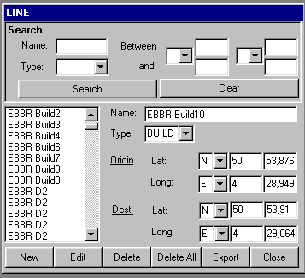

The screen is divided into 4 areas:
- the Search area above
- the List on the left
- the Menu area below
- the Data area on the right

The Search area allows you to enter selection criteria. Lines corresponding to those criterias are listed in the list. The Data area displays information about the item selected in the List.

Note: the “Glide slope (°)” text box is only available for lines having “APP” as Type.

To make a selection:
Enter your criteria. Possible criterias are:
Name (wildcards * and ? are allowed)
Type (select from the combo-box)
Latitude text: N or S
Latitude degrees between X and Y
Longitude text: E or W
Longitude degrees between X and Y
Click the “Search” button: the List will display the list of lines corresponding to all criteria.
Click on one item in the list to see the item’s data.

Here are some examples:
Example 1:
Name: A*
Type: HRUN
Lat Text: N

Result: the List will display all high runways beginning with an “A” with the start or the end in the North hemisphere.

Example 2:
Type: GEO
Lat Text: N
Lat Degree between: 50

Result: the List will display all geographical lines starting or ending above 50° in the North hemisphere.

Example 3:
Lat Text: N
Lat Degree between: 50
Lat Degree and: 55
Long Text: E

Result: the List will display lines starting or ending between 50° and 55° in the North East hemisphere.

Note 1: None of the criteria are required.
Note 2: There are no criteria on the minutes of Latitude or longitude.
Note 3: There is no possibility to display all data between a North co-ordinate and a South co-ordinate or between an East co-ordinate and a West co-ordinate: you must execute 2 separate searches.

To display all data:
Click the “Clear” button: the List will display all the list of lines.
Click on one item in the list to see his data.

To add a new line:
Click the “New” button: the Data area will display a blank screen.
Fill out the data.
Click the “Save” button to save the new line.
Or
Click the “Cancel” button to discard the new line.

To edit a line:
Click the “Edit” button.
Modify the data.
Click the “Save” button to save your changes.
Or
Click the “Cancel” button to discard the your changes.

Note 1: During the creation or editing of a line, the List, the Search and the Close buttons are disabled. You must first save or cancel your changes before displaying another line or closing the screen.
Note 2: There is no possibility to undo changes saved to a line.

To help you out:
- If an item is missing, you will receive a message stating which one is missing.
- If an item is incorrectly filled out (text where numbers are required), you will receive a message stating which one is wrong.

To delete the current line:
Click the “Delete” button.

Note: There is no possibility to undelete a deleted line.

To delete all lines in the current selection:
Click the “Delete All” button.

Note: There is no possibility to undelete a deleted selection.

To export all lines in the current selection:
Click the “Export” button.

CH Data Manager will generate a text file in a specific text format (called CH Format). The file is created in the same folder where CH Data Manager is installed. The filename is “LineXXXX.chf” where XXXX is an incremental number.

Useful tips:
- You can change the filename of the exported file. However, do not change the extension.
- You can add comment lines in the exported file. A comment line must begin with “;” character. Do not add a comment after a data line.
- You can open an export file with a text editor, such as Notepad.
- You can mix separate export file. Open both files with a text editor and copy data from the first file into the other.
- You can mix data exported from the ICAO screen and data exported from the LINE screen (see above) in one CH data file.

JH Capture

JH Capture has been originally designed and programmed by Johan Hooyberghs, member of the Flight Simulator Club Belgium. JH Capture has been included in the CH Database Manager with his permission.

JH Capture will be displayed as a screen inside FS. You can then place the plane on a specific position and store this position directly in the CH Database. So you can easily draw an airport layout.

To start JH Capture:
Start Flight Simulator
Start JH Capture

JH Capture will be displayed inside FS. It looks like the following screen:
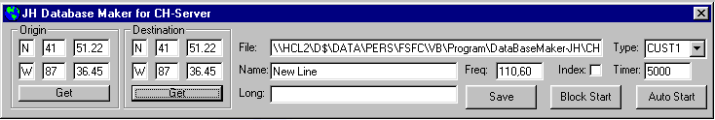

To help you:
- The easiest way to place the plane on the required location is to display the top-down view on full screen and to use the “Slew” mode.

You can save data into the CH Database by using one of the following modes:
- Manual mode
- Block mode
- Auto mode

Manual mode:
To save a point or a line in Manual mode:
- Place the plane on the desired location
- Type the correct path in the “File” text-box
- Type a name in the “Name” text-box
- Select a line type in the “Type” combo-box
- Click the “Get Origin” button
- Place the plane on the new location
- Click the “Get Destination” button
- Click the “Save” button”

Note: the “LongName” and “Frequency” text-boxes are only used if “ARP”, “VOR” or “NDB” is selected in the “Type” combo-box.

If Flight Simulator is the active window (not JH Capture), you can save a point or line by pressing the “Insert” key instead of pressing the “Save” button.

Block mode:
The “Block mode” will help you to save consecutive lines, where the start of a line is in the same position that the end of the previous line.

To save a point or a line in Block mode:
- Place the plane on the desired location (then start the first line)
- Type the correct path in the “File” text-box
- Type a name in the “Name” text-box
- Select a line type in the “Type” combo-box
- Click the “Get Origin” button
- Click the “Block Start” button
- Place the plane on the new location
- Click the “Save” button”
- Repeat the 2 last steps for the following lines

If Flight Simulator is the active window (not JH Capture), you can save a point or line by pressing the “Insert” key instead of pressing the “Save” button.

To stop the Block mode:
Click the “Auto Stop”

Auto mode:
The “Auto mode” is only available when the “Block mode” is active. It will save lines on a timed basis.

To save a point or a line in Auto mode:
- Place the plane on the desired location (the start of the first line)
- Type the correct path in the “File” text-box
- Type a name in the “Name” text-box
- Select a line type in the “Type” combo-box
- Select an interval in the “Timer” text box (range is from 1 ms to 60000 ms)
- Click the “Get Origin” button
- Click the “Auto Start”
- Plane the plane on the new location
- Repeat the last step

To stop the Auto mode:
Click the “Auto Stop”

To close JH Capture:
Click the “Close” button

Note: if you close FS while JH Capture is running, you will receive an error message from JH Capture.

CH Format
This is the first item in the Import menu.
It allows you to import data from files in CH Format. Files in CH Format are generated by the Export feature of the ICAO and LINE screens.
When opened, the Import CH Format screen looks like the picture below:
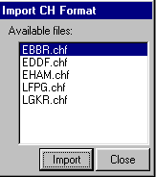

The “Available files” list displays the list of all files having the “.chf” extension and in the same folder as CH Data Manager.

To import a file:
Select the chosen file in the “Available files” list.
Click the “Import” button.

Note 1: There is no possibility to undo an import.
Note 2: Data from the file is always appended to existing data.

To help you out:
- You can open a CH Format file with a text editor beforehand. That way you can check the file contents.

To close the screen:
Click the “Close” button.

Prabal’s database
This is the second item in the Import menu.
It allows you to import data from the Prabal’s Worldwide Navigation database.

To import the Prabal’s database:
- Download the latest version of the database from Prabal’s web site: http://drive.to/prabal or
http://members.home.net/pgnav/.
- Unzip all 5 files in the same folder as CH Data Manager.
- Click the “Import” menu.
- Select “Prabal’s database”: the Import Prabal’s database screen appears. It looks like the
picture below:
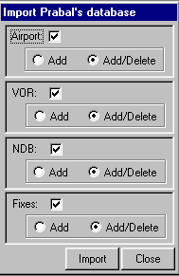
Mark the check-box(s) for the data you wish import:
Note: if you did not copy all 4 files, the Check-box for the missing files will not be available.
Select “Add” to add the selected data to the existing data.
Or
Select “Add/Delete” to first delete the corresponding existing data then add the new data.
Note1: if you select “Add” and there is already data in the CH Database, you will have double entries.
Note2: if you select “Add/Delete”, all corresponding existing data will be deleted, including the one you manually encoded.
Click the “Import” button.

Note: There is no possibility to undo an import.

Useful tips:
- If you wish to keep data you entered in the CH Database, you can export that data, import the Prabal’s database, then import your data again. If you keep your export, you can use it the next time you wish to update the CH Database with Prabal’s database.

To close the screen:
Click the “Close” button.

USGS database
This is the third item in the Import menu.
It allows you to import data in from the USGS Navigation database.

To import data from the USGS database: Download the requested data from the Coastline Extractor page: http://crusty.er.usgs.gov/coast/getcoast.html.
Note: always select Zip, Mapgen, No Preview.
Unzip the file in the same folder as CH Data Manager.
Click the “Import” menu.
Select “USGS database”: the Import USGS database screen appears. It looks like the picture below:
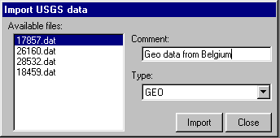
Select the file in the “Available file” list.
Add a comment in the “Comment” text box.
Note: The comment will be displayed in the “Name” field for the LINE screen.
Select a type in the “Type” combo-box. Typically:
For coast lines: GEO
For rivers: WATER
For political boundaries: GEO or one of the CUST
Click the “Import” button.

Note1: There is no possibility to undo an import.
Note2: Data from the file are always added to existing data.

To close the screen:
Click the “Close” button.

Update to V3
This is the only item in the Update menu.
When opened, the Update to V3 screen looks like the picture below:
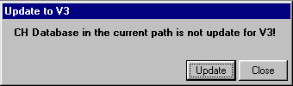
If you got this screen, your CH Database is not up to date for V3.
To update the CH Database to V3
Click the “Update” button.
The screen should now display:
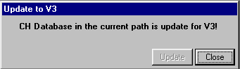
To close the screen:
Click the “Close” button.

Credits
Many thanks to:
Peter Dowson: for developing the FSUIPC
Ghosh Prabal: for maintining his Worldwide Navigation database and for allowing me to use it with CH Programs.
Johan Hooyberghs: member of the Belgium Flight Simulator Club: for writing JH Capture and allowing me to include it in my program, for making detailed airport layouts and for many other things.

Disclaimer
CH Programs comes with no warranty or claim of fitness or reliability.
CH Programs is distributed AS IS, USE AT YOUR OWN RISK. The author of CH Programs has absolutely no affiliation what so ever with Microsoft® Corporation. Neither the author of CH programs, nor Microsoft Corporation shall be held responsible for any loss of data, down time, loss of revenue or any other direct or indirect damage or claims caused by CH Programs or FILES USED IN CONJUNCTION with CH Programs.

Redistribution Terms
CH Programs is SHAREWARE, and:
- MAY NOT BE sold.
- MAY NOT BE uploaded to, nor archived in, BBSs which charge file download fees.
- MAY NOT BE uploaded to, nor archived in, BBSs which are partly or wholly beneficially owned or operated by a commercial enterprise which is engaged in the sale of computer hardware or software.
- MAY NOT BE redistributed with computer hardware or software for which money is charged.
- MAY NOT BE redistributed by a commercial publisher in any form or under any pretext.
- MAY NOT BE redistributed on floppy disk, CD-ROM, nor in any other printed or electronic storage form for which money is charged, nor as part of a package for which money is charged. This prohibition includes but is not limited to any form of redistribution for which any type of materials or handling fees are charged.
- MAY NOT BE disassembled, decompiled, decomposed, decoded, nor reverse engineered.

Subject to the exclusions listed above, the archive containing CH Programs may be uploaded to BBSs and otherwise redistributed on a SHAREWARE basis as long as the original contents are not modified in any way.

THERE ARE NO EXCEPTIONS to the redistribution terms stated above without the prior written permission of the author.

Copyrights
The CH Programs carry the following copyright:
Copyright © 1998-2001 by Claude Hanssens. All rights reserved.
Microsoft Flight Simulator is a trademark of Microsoft Corporation.
WiZip® is a registered trademark of WinZip Computing, Inc.
FSUIPC.DLL has a copyright © 1999-2001 by Peter Dowson.
JH Capture has a copyright (C) by Johan Hooyberghs

